***SS LAB***

***EXPERIMENT # 05 ( DFT AND IDFT)***

***NAME: ADITYA PRATAP SINGH***

***ROLL NO. : 16 EC01028***

***OBJECTIVE:***

1. To demonstrate the discrete Fourier transform (DFT) for discrete time domain signal
2. To demonstrate the inverse discrete Fourier transform (IDFT) for discrete frequency domain signal.

***MATLAB CODE:***

clc; close all ;clear all;

t1 = 0:1:49; t2 = 0:1:99; N1 = 50 ; T1 = 1/100; N2 = 100; T2= 1/50;

for n = 0:N1-1

F1(n+1,1) = T1*sin(20*pi*n*T1); %part A-(i)

F4(n+1,1) = triangularPulse(2*pi*(n-8)/N1); %part B-(i)

end

for n = 0:N2-1

F2(n+1,1) = T2*exp(1i*2*pi*(31/3)*n*T2); %part A-(ii)

F3(n+1,1) = 3*power(0.8,n*T2)*cos(0.1*pi*n*T2); %part A-(iii)

F5(n+1,1) = 1/(1-(5*exp(-1i*12*pi*(n/N2)))); %part B-(ii)

end

printDFT(F1 , N1 ,t1); figure(); printDFT(F2 , N2 ,t2); figure();

printDFT(F3 , N2 ,t2); figure(); printIDFT(F4 , N1 ,t1); figure();

printIDFT(F5 , N2 ,t2);

***Function::***

1.function [out] = omega(n)

om = 2*pi/n;

for i=0:n-1

for j=0:n-1

k = i*j;

out(i+1,j+1) = cos(om*k)-1i*sin(om*k);

end

end

end

2. function [out] = printIDFT( input ,N,t)

subplot(4,2,[1,2]);

stem(t,transpose(input)) ; title('Input Function'); ow = 2*pi/N;

for i = 0:N-1

sum(i+1) = 0;

for j = 0:N-1

sum(i+1) = sum(i+1) + input(j+1,1)*exp(1i*ow*i*j);

end

sum(i+1) = sum(i+1)/N;

end

subplot(4,2,3); stem(t,angle(sum)); title('Angle of IDFT');

subplot(4,2,4); stem(t,abs(sum)); title('Magnitude of IDFT');

Y = ifft(input);

subplot(4,2,5); stem(t,angle(Y)); title('Angle of In-built Fn');

subplot(4,2,6); stem(t,abs(Y)); title('Magnitude of In-built Fn');

Lec_input = conj(input);

X = conj(omega(N)*Lec_input)./N;

subplot(4,2,7); stem(t,angle(X)); title('Angle of lec-IDFT');

subplot(4,2,8); stem(t,abs(X)); title('Magnitude of lec-IDFT');

end

3. function [out] = printDFT( input,n,t )

subplot(3,2,[1,2]); stem(t,transpose(input)) ; title('Input Function');

subplot(3,2,3);

X = omega(n)*input; stem(t,angle(X)); title('Angle of DFT');

subplot(3,2,4); stem(t,abs(X)); title('Magnitude of DFT');

Y = fft(input);

subplot(3,2,5); stem(t,angle(Y)); title('Angle of In-built Fn');

subplot(3,2,6); stem(t,abs(Y)); title('Magnitude of In-built Fn');

end

***FIGURES::*** Part A-(i)

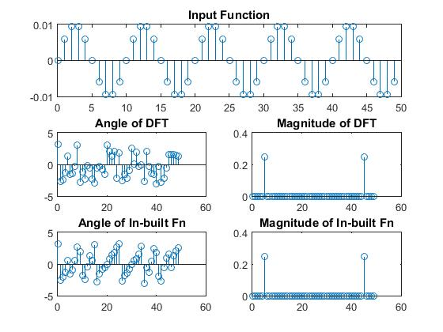

Part A-(ii)

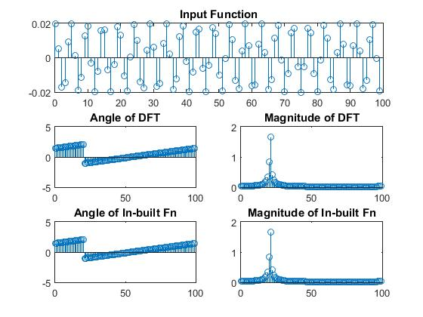

Part A-(iii)

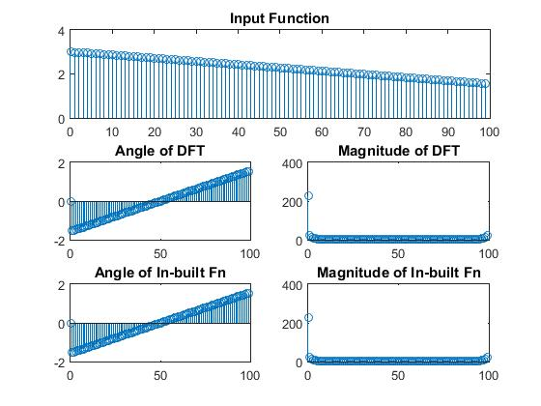

Part B-(i)

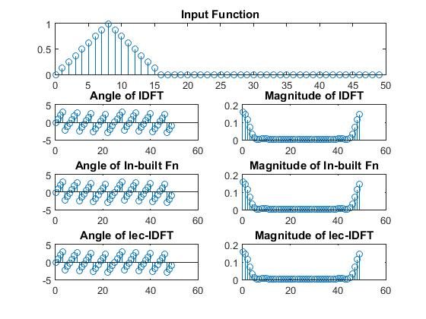

Part B-(ii)

